**Installation of Hyperledger Fabric in Windows**

1. Install Docker Desktop ( version 4.1.1 because it is stable and support Hyperledger Fabric)

* <https://docs.docker.com/desktop/release-notes/>

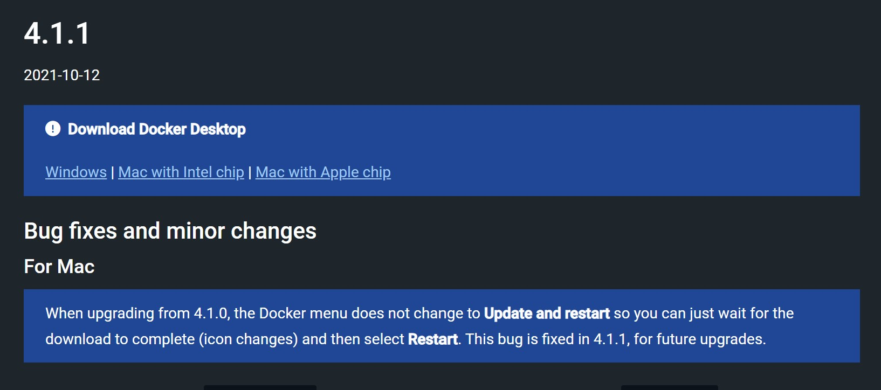

1. Now, Search “turn Windows features on or off”

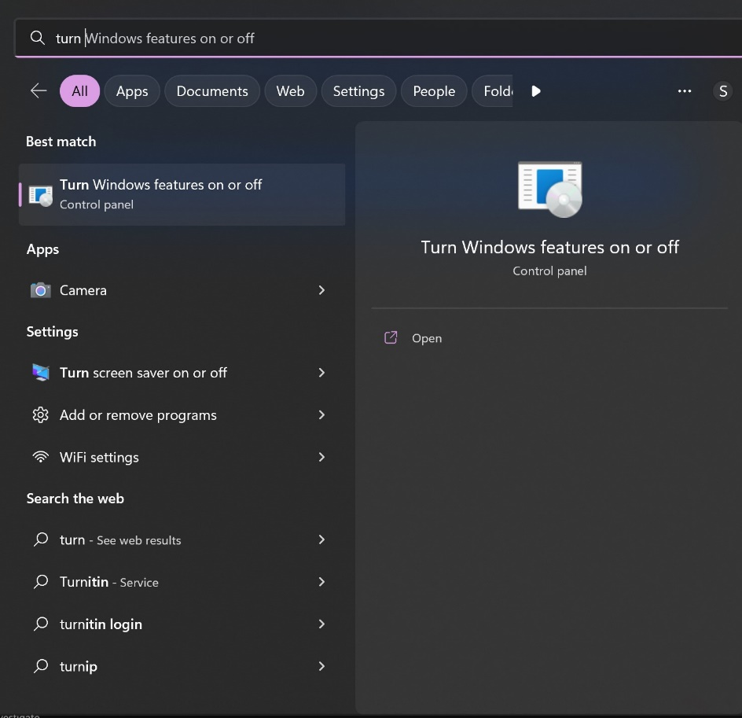

Open it and check these boxes.

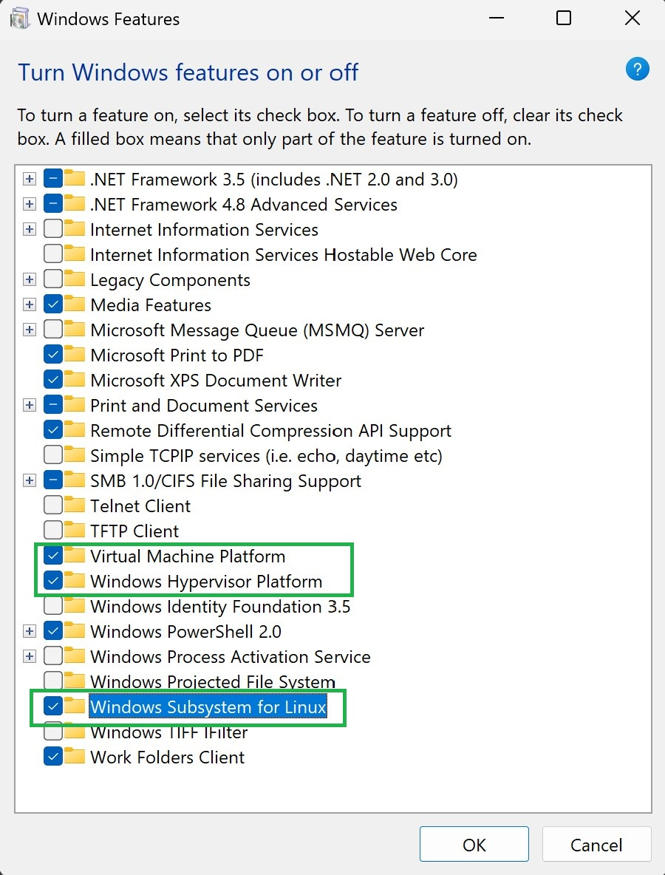

And also check “Hyper-V” if showing.

Then click **OK**

1. Restart your laptop or pc.
2. Now search “Windows PowerShell”

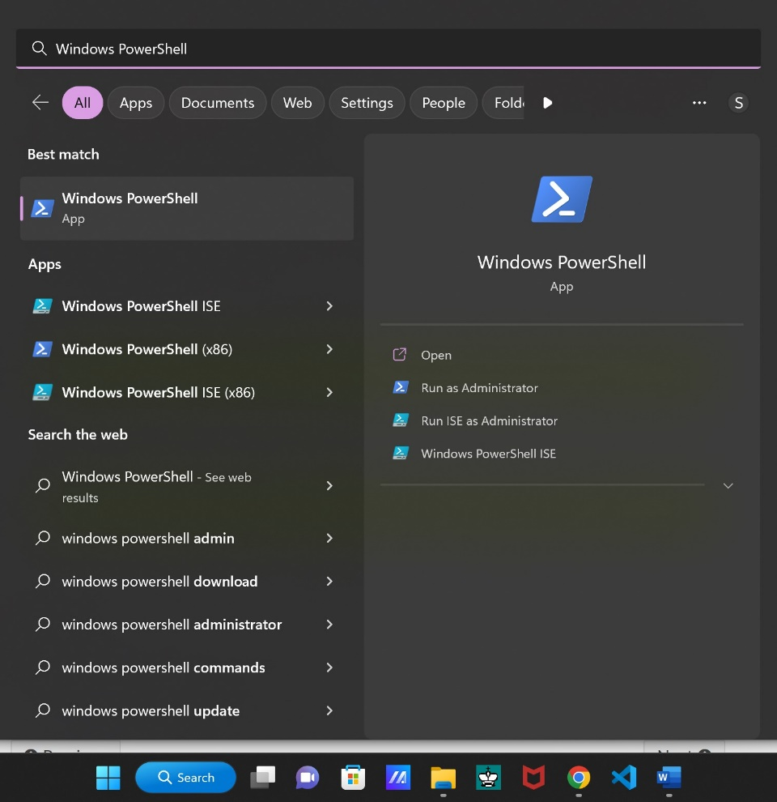

Open it.

And write “ wsl --install”

Then Enter

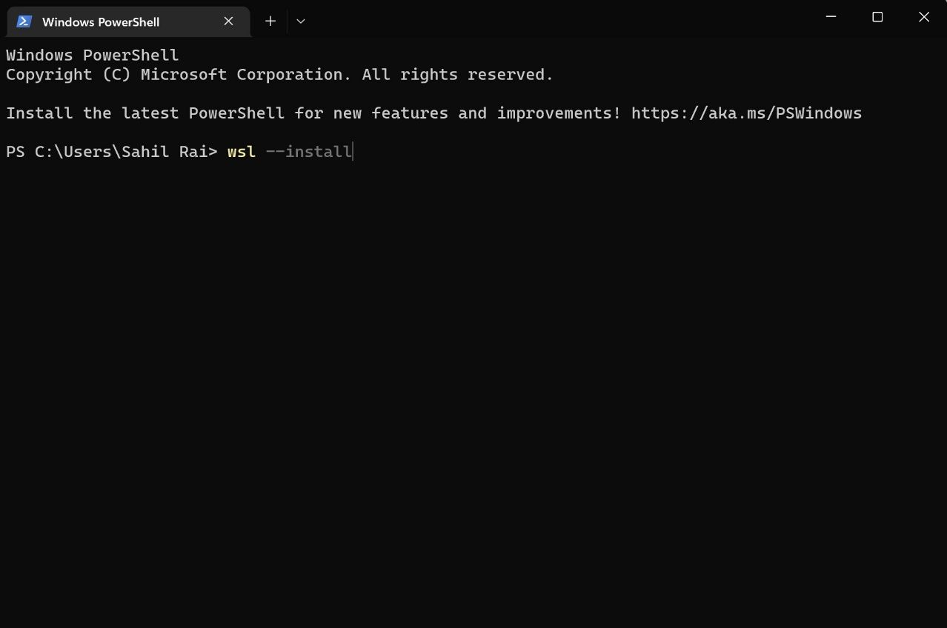

If you have already install wsl then it look like below image.

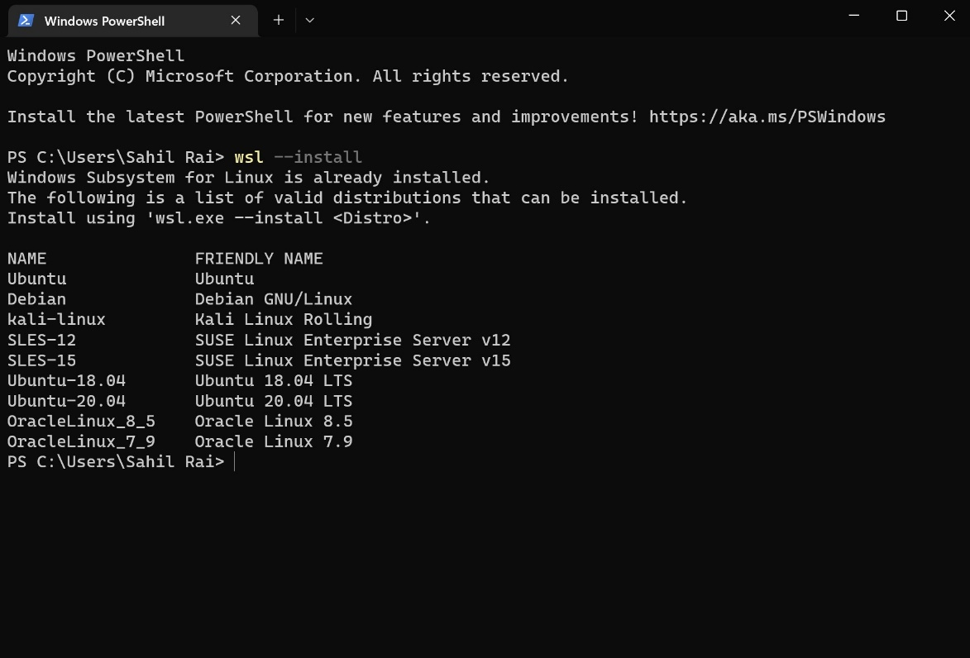

And if it is not install then the above command will install the wsl.

If any error occurs while installing wsl then go to below link.

<https://learn.microsoft.com/en-us/windows/wsl/install>

1. Now after installing wsl ,write this command in PowerShell

“ wsl --set-default-version 2 ” and then press enter.

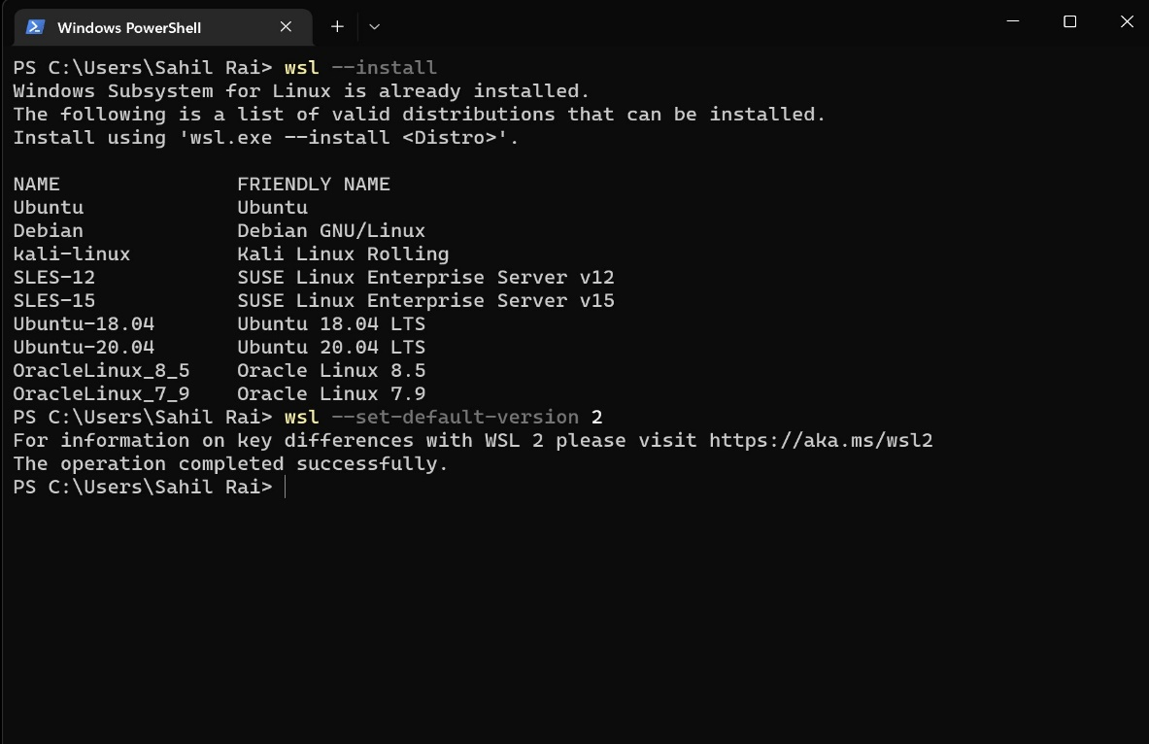

1. Open Microsoft Store and Search Ubuntu.

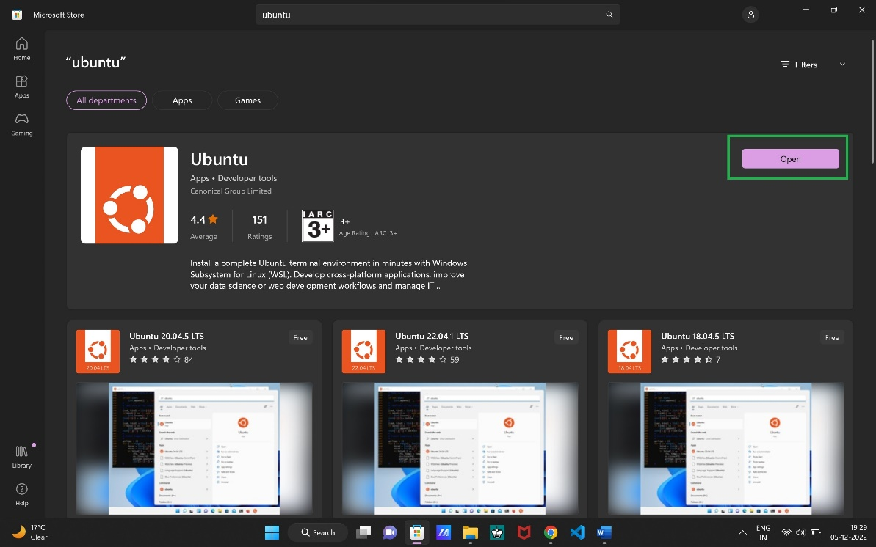

And install it. If not installed with wsl.

Then restart your pc or laptop.

1. Open ubuntu and set username and password.

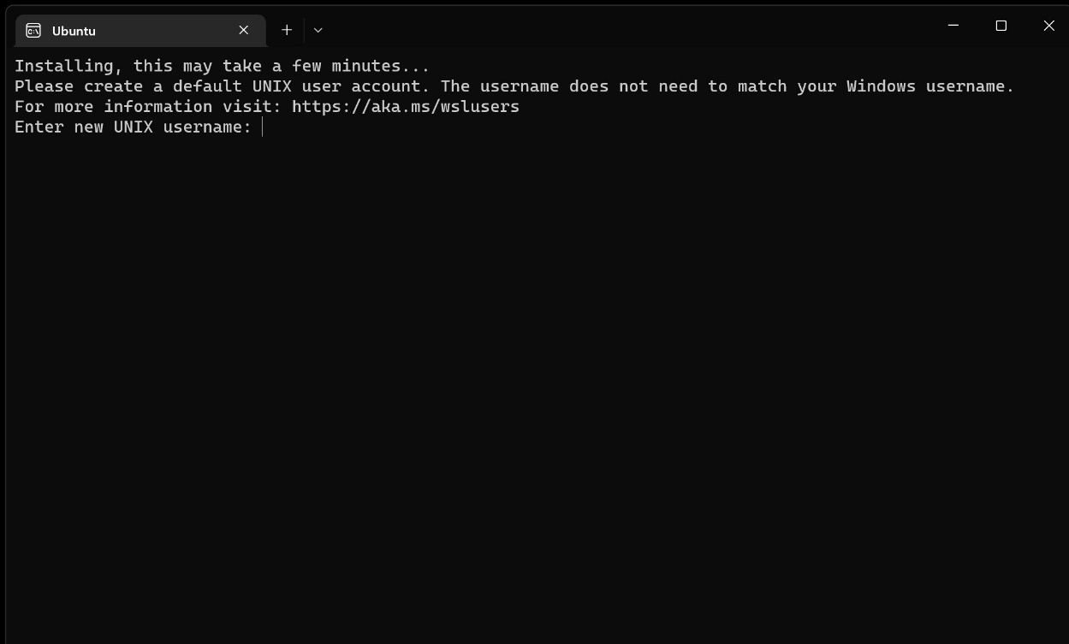

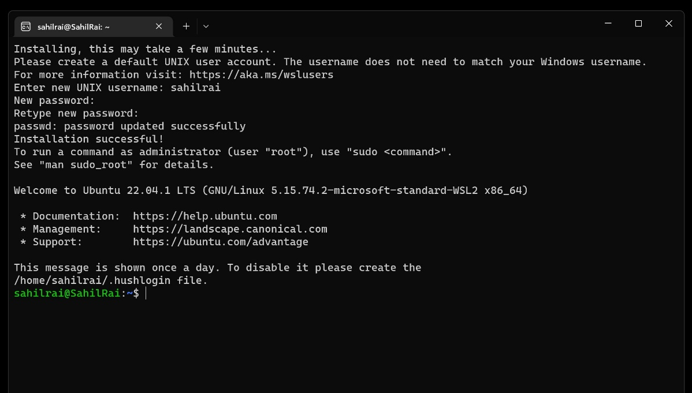

1. Now install docker desktop which we downloaded in **step 1.**

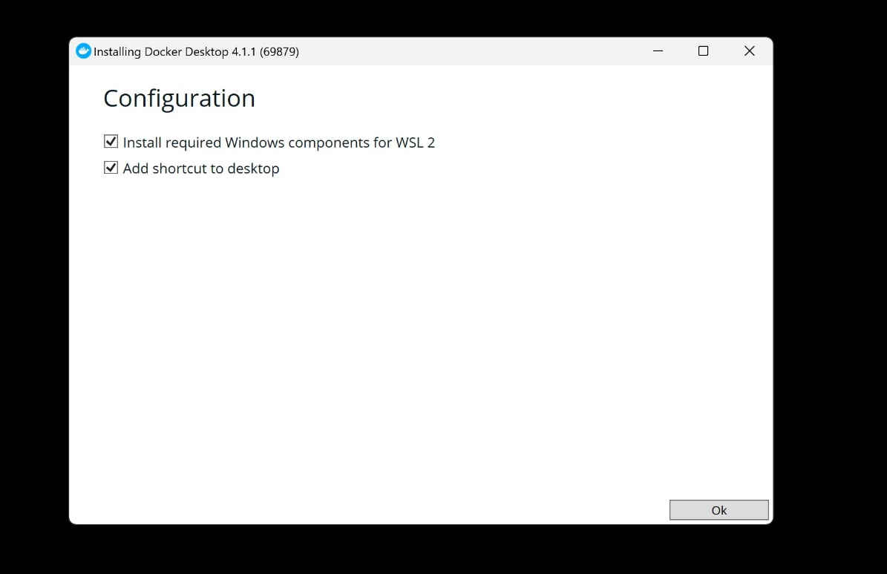

Click **OK**.

Wait for few minutes…

After Installation

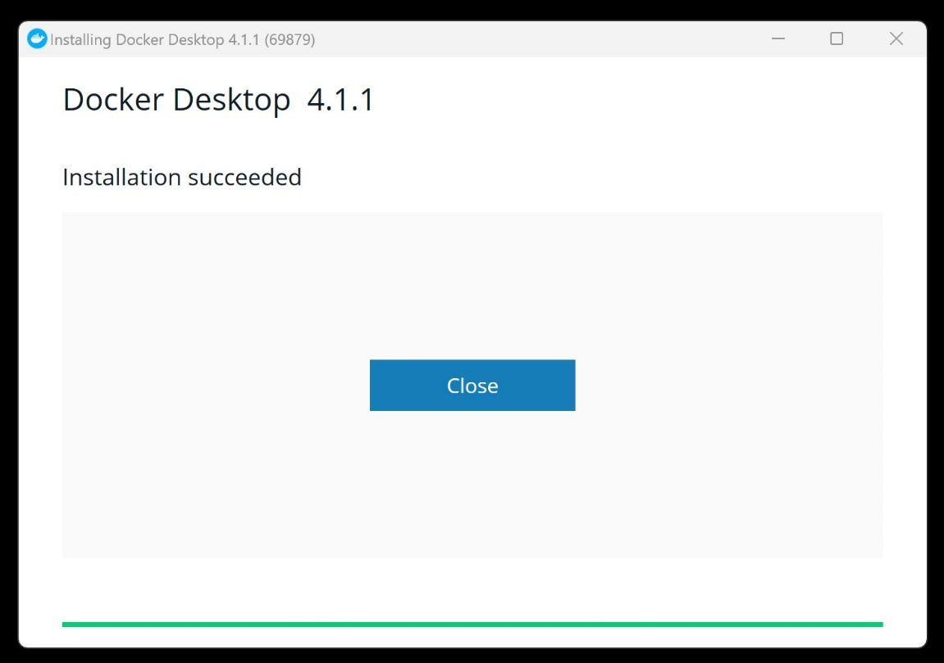

Now click on close.

And Restart PC or laptop.

1. Open docker desktop 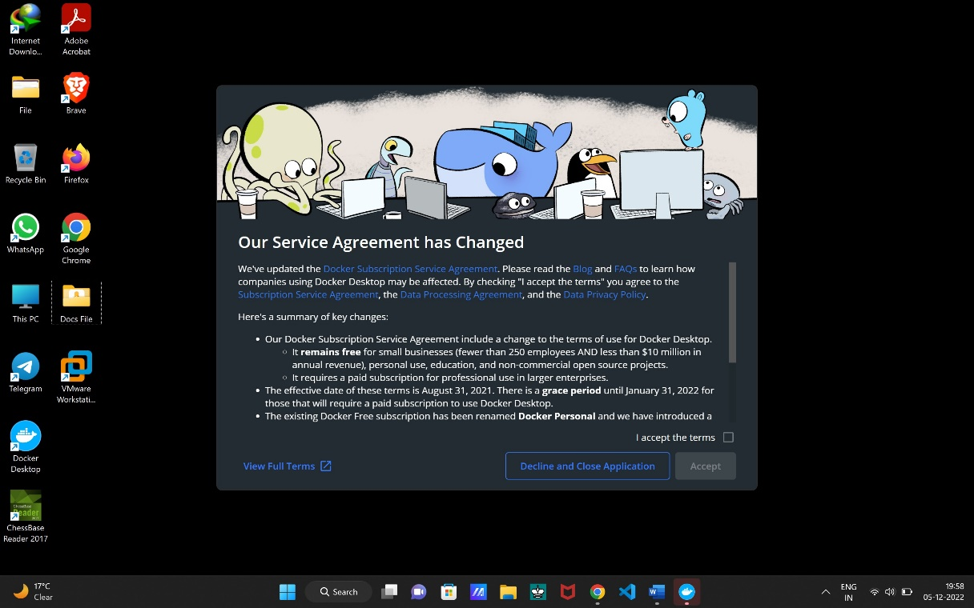

Now check accept the terms and click on **Accept.**

And skip tutorials.

After that go to the settings.

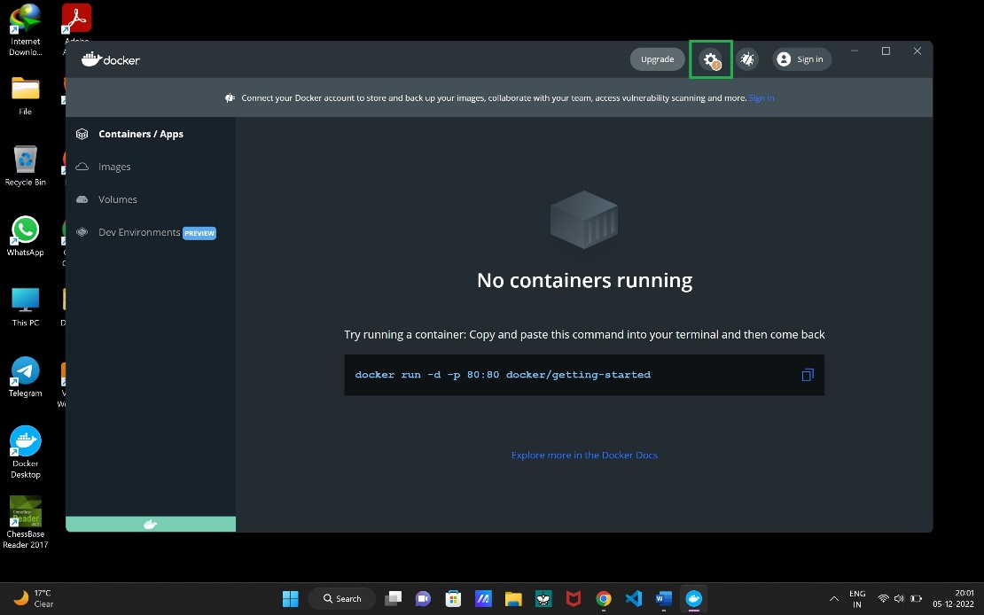

Then go to Resources ( Don’t update docker desktop ).

Then go to wsl integration and enable ubuntu.

After that Click Apply and restart.

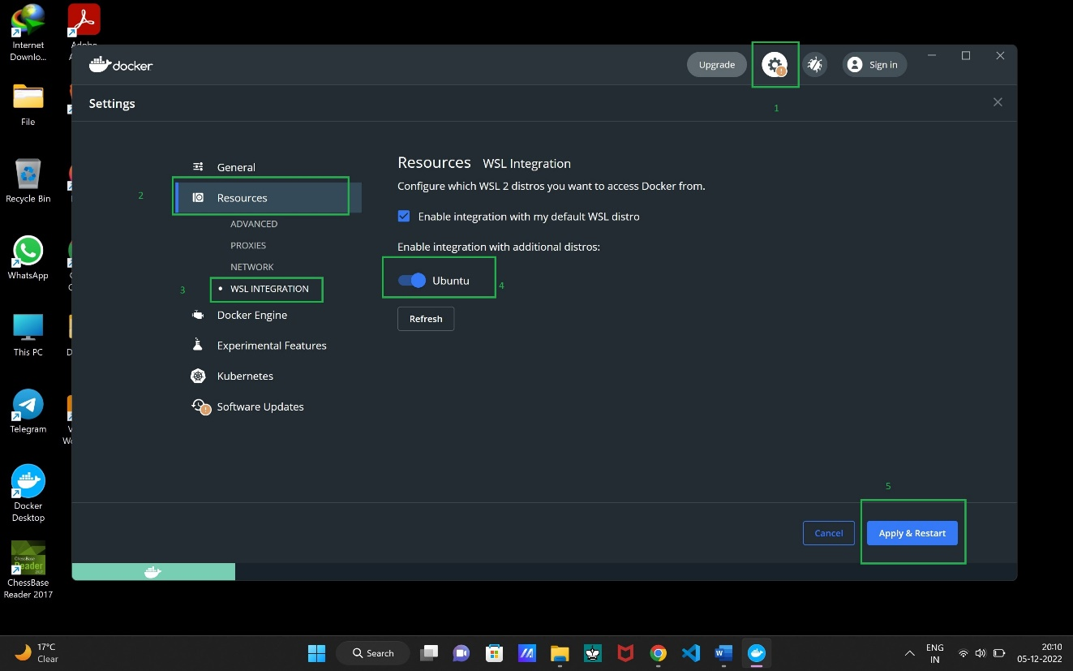

Then restart your pc or laptop.

1. Open task manager and go to Startup apps.

And enable docker desktop.

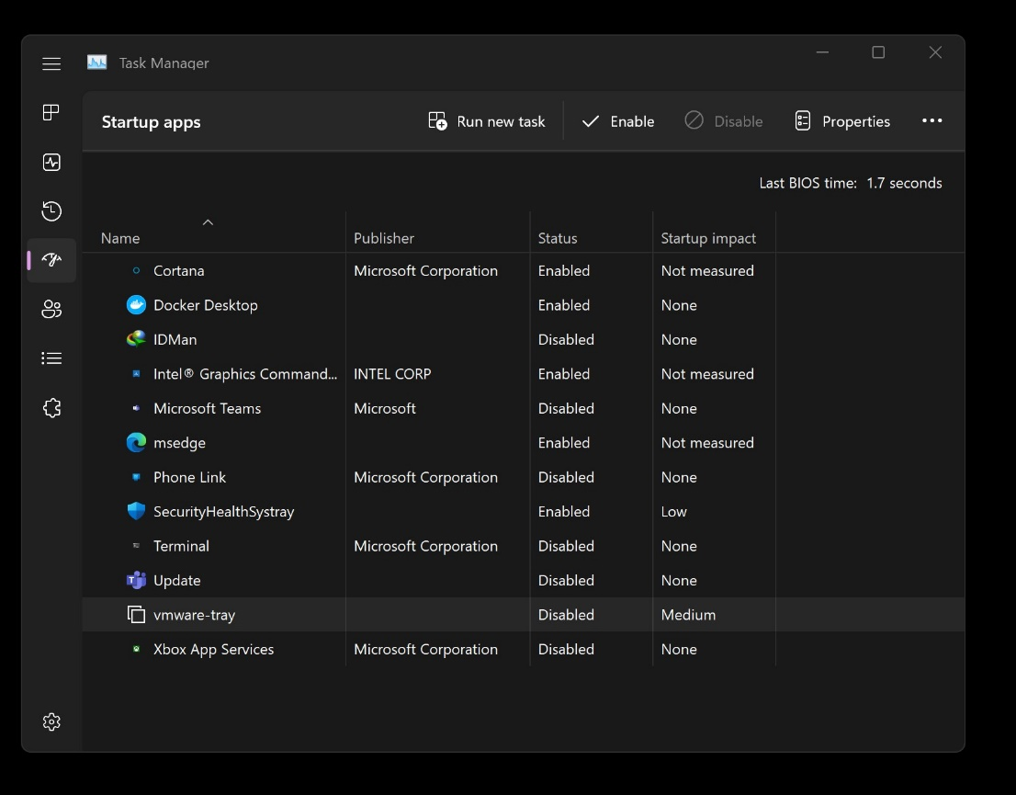

1. Now go to the Hyperledger docs website given below.

<https://hyperledger-fabric.readthedocs.io/en/release-2.5/prereqs.html>

Now install the Prerequisites for Linux.

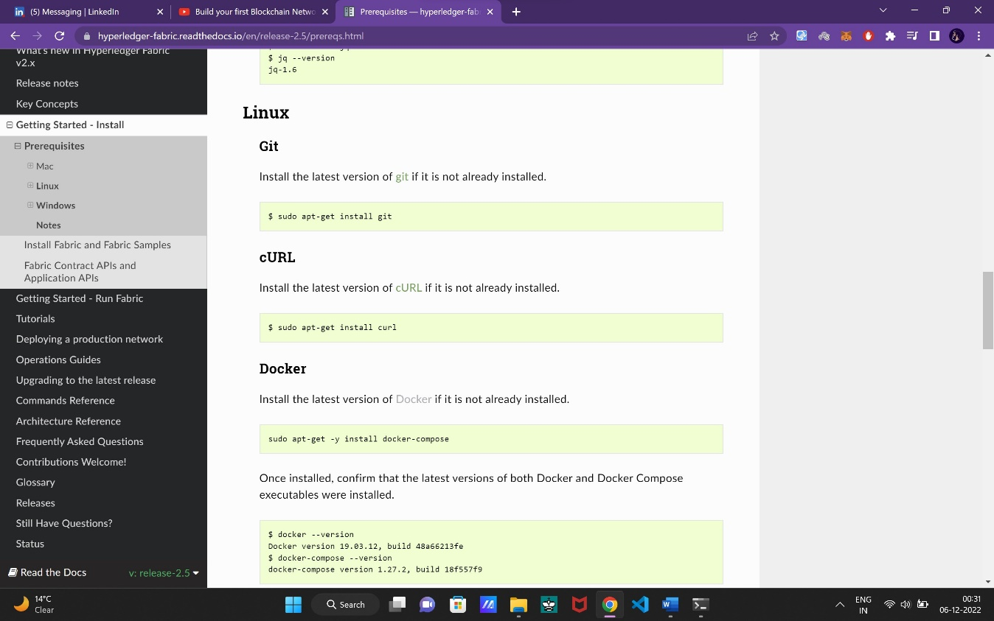

* sudo apt-get install git

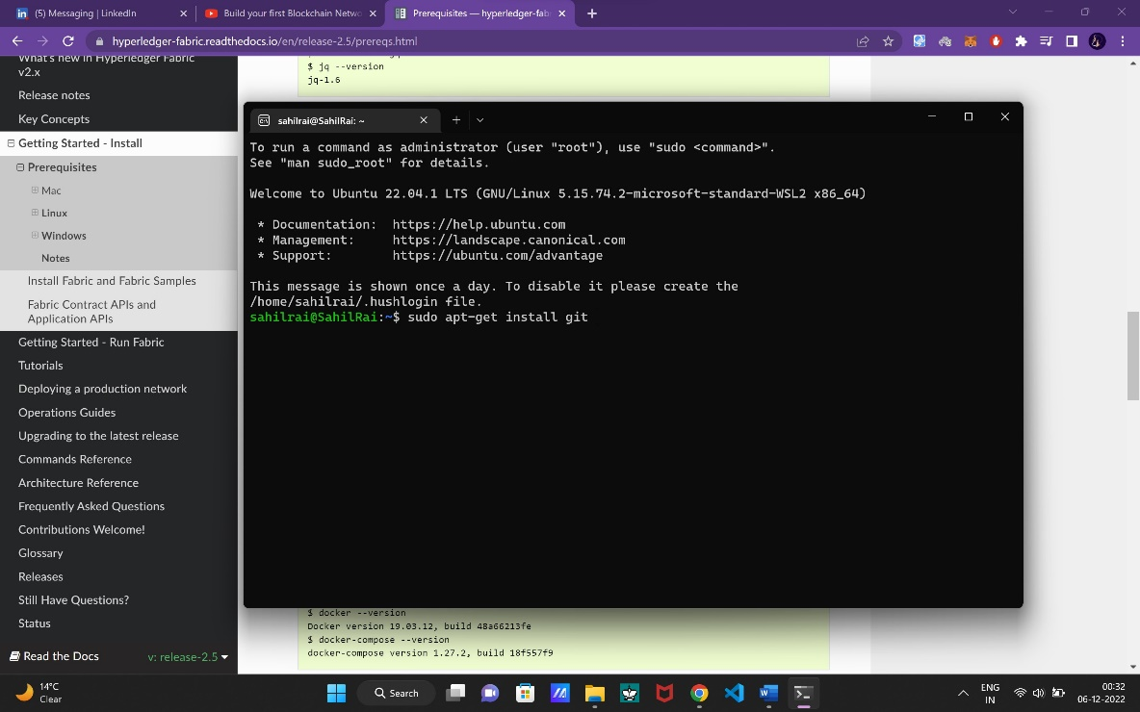

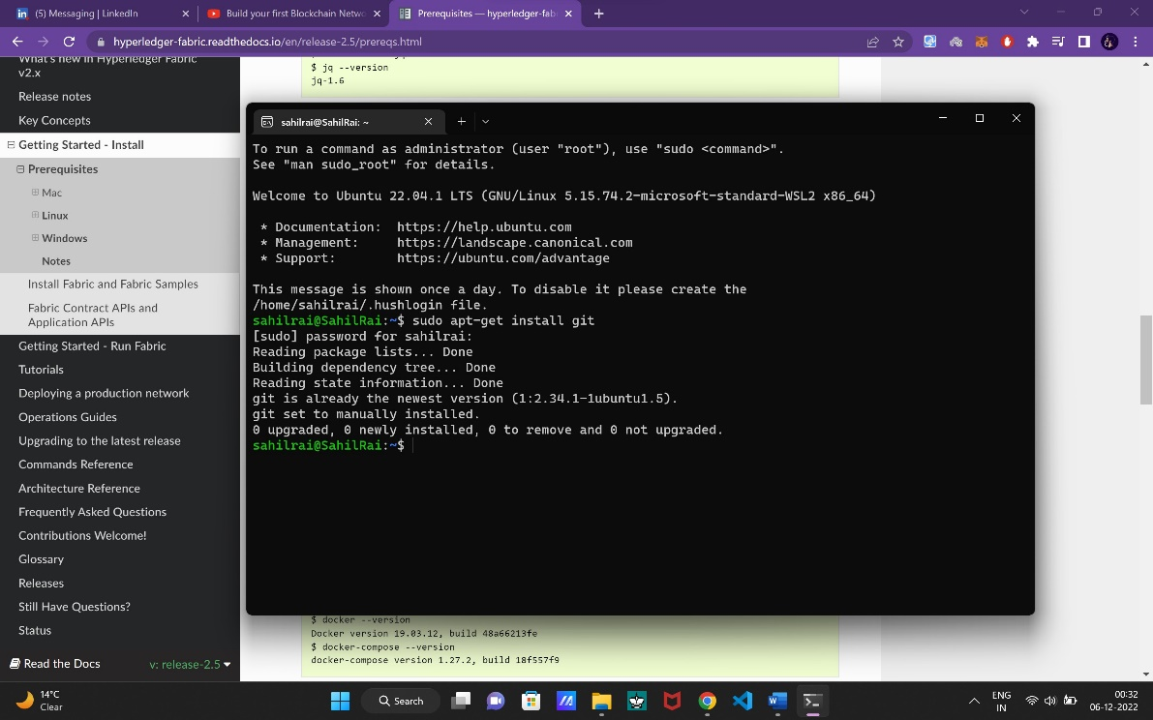

* sudo apt-get install curl

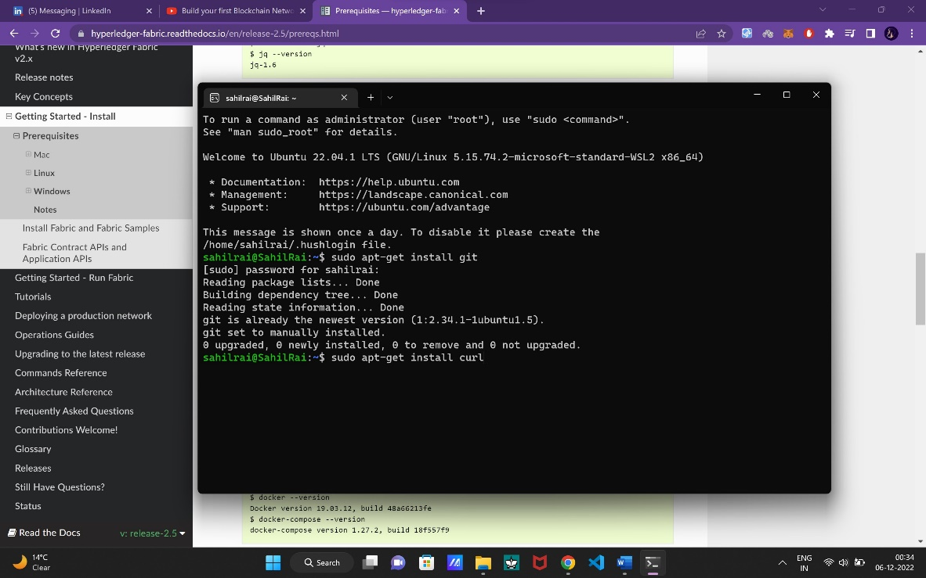

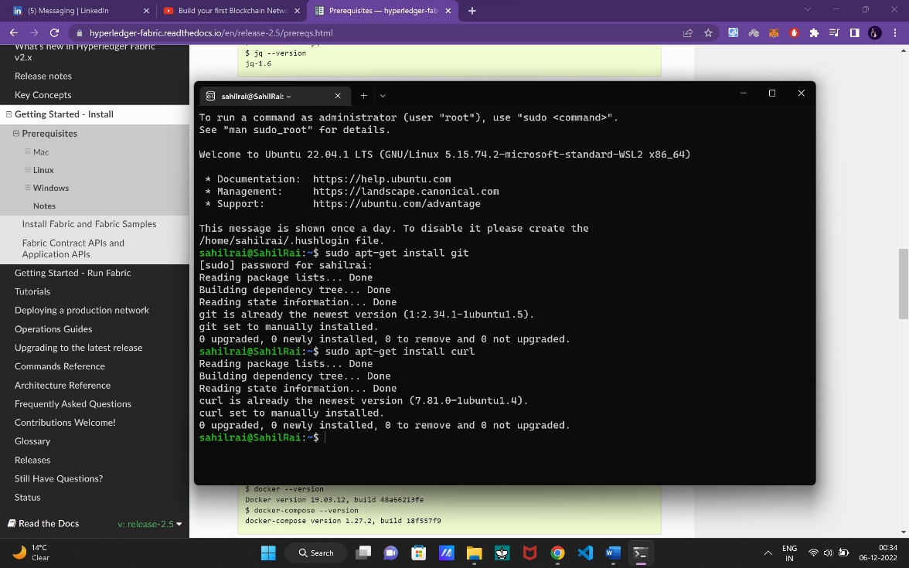

* docker --version
* docker-compose –version

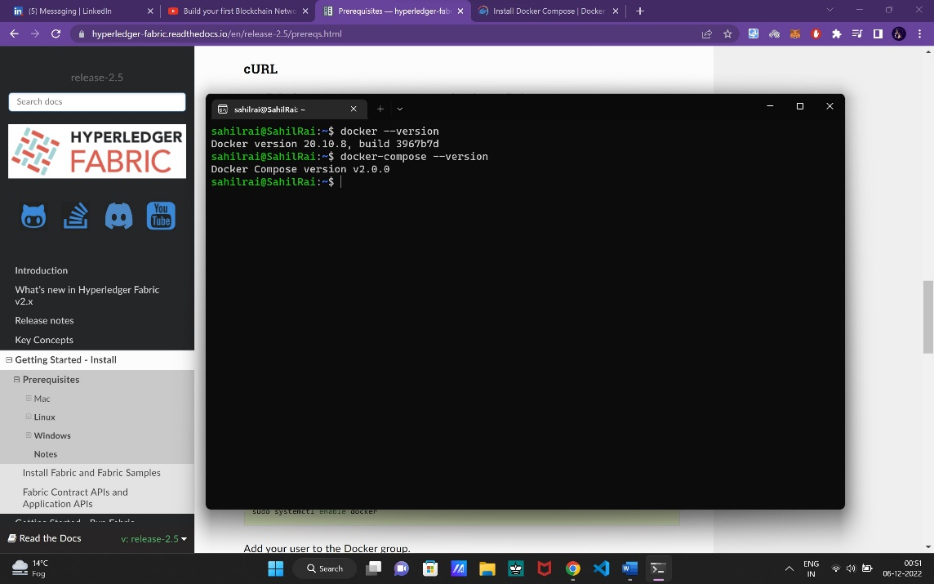

1. **Copy and run the command.**

sudo curl -L https://github.com/docker/compose/releases/download/v2.6.0/docker-compose-`uname -s`-`uname -m` -o /usr/local/bin/docker-compose

1. **And after that run this command.**

* sudo chmod +x /usr/local/bin/docker-compose
* docker-compose –version

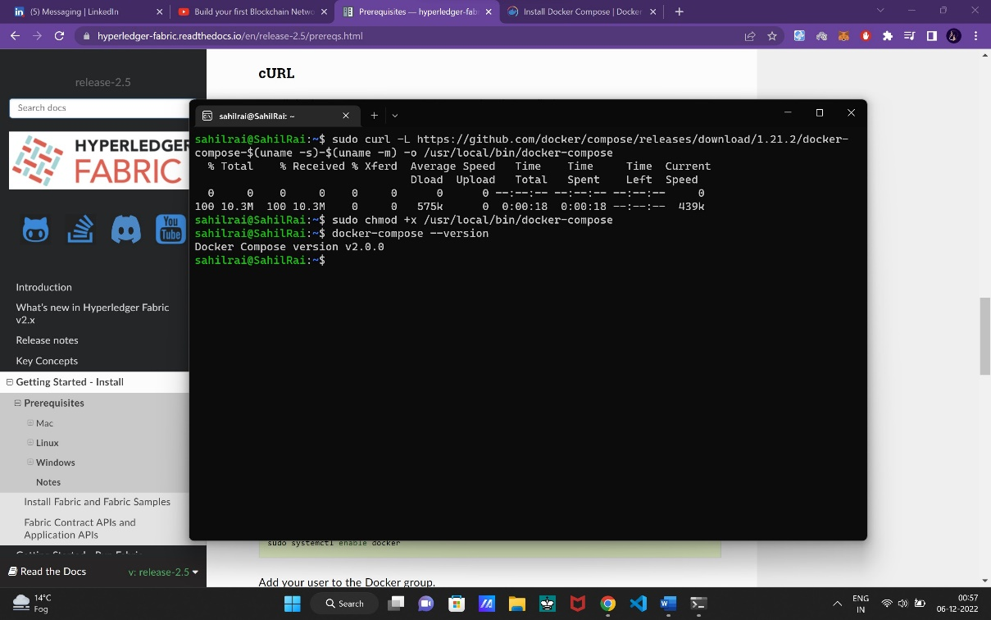

1. run the below command in ubuntu

download the latest version of go.

wget <https://go.dev/dl/go1.13.5.linux-amd64.tar.gz>

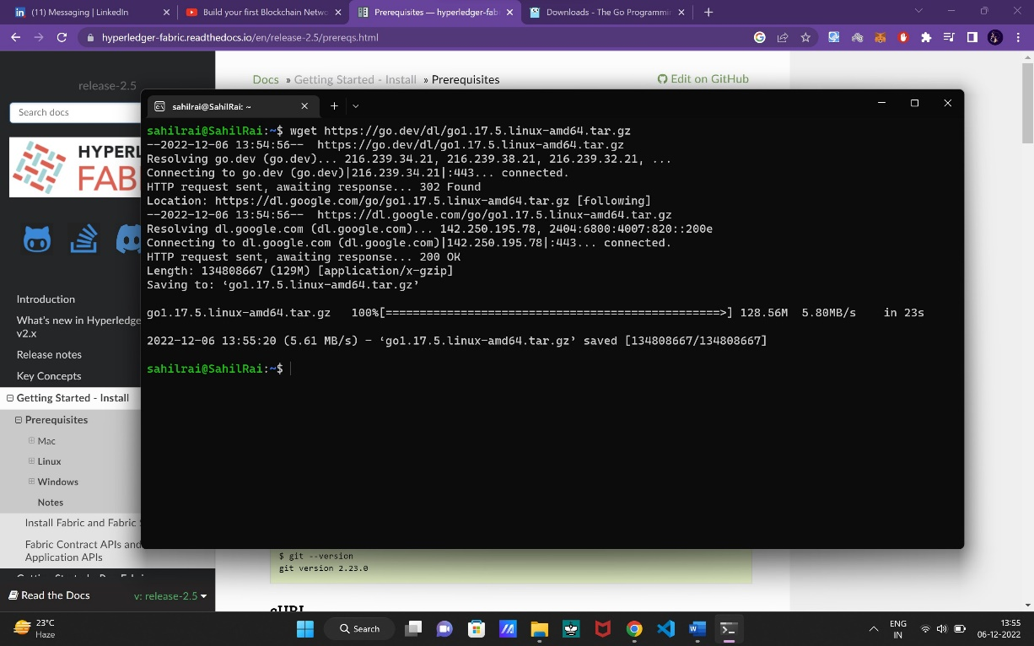

Use go1.13.5 version not 1.19.x

1. Type “ls” to see it is downloaded or not.

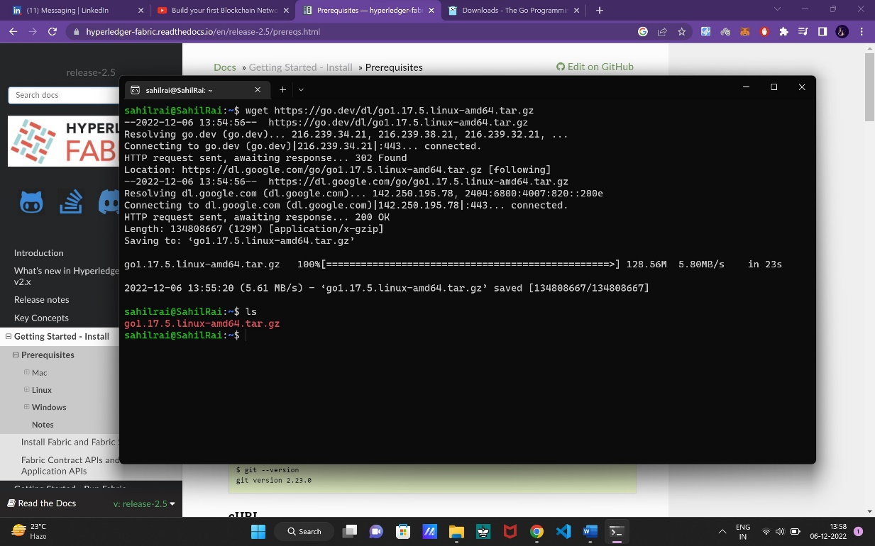

1. Run the below command

sudo tar -xvf go1.13.5.linux-amd64.tar.gz

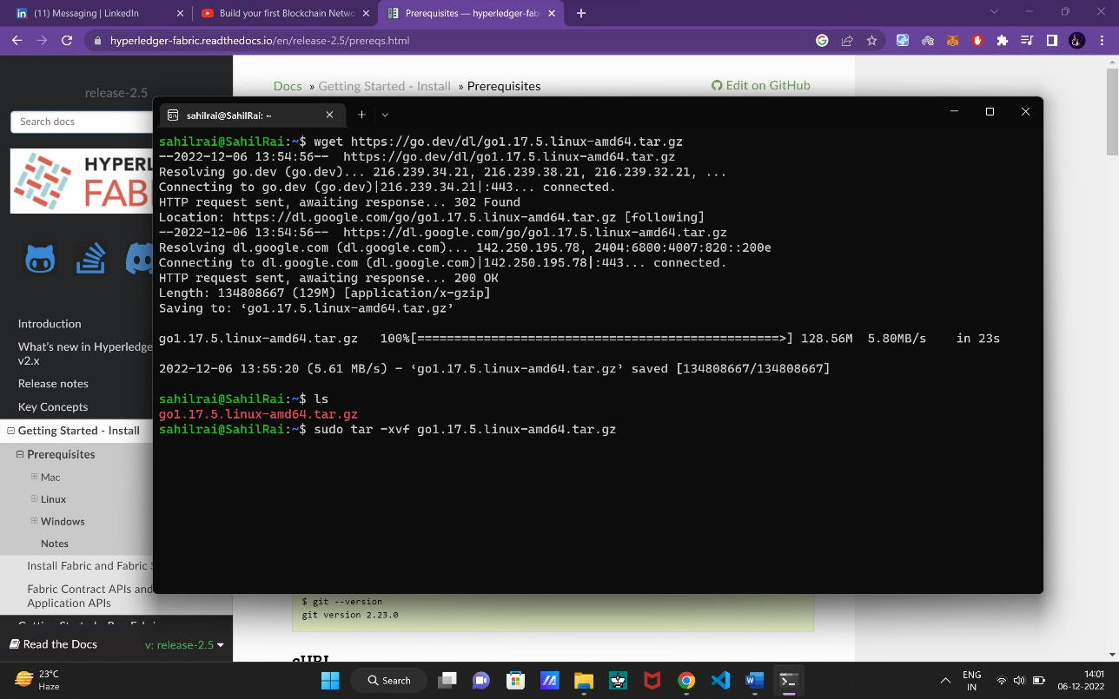

This command extract the go1.13.5 file.

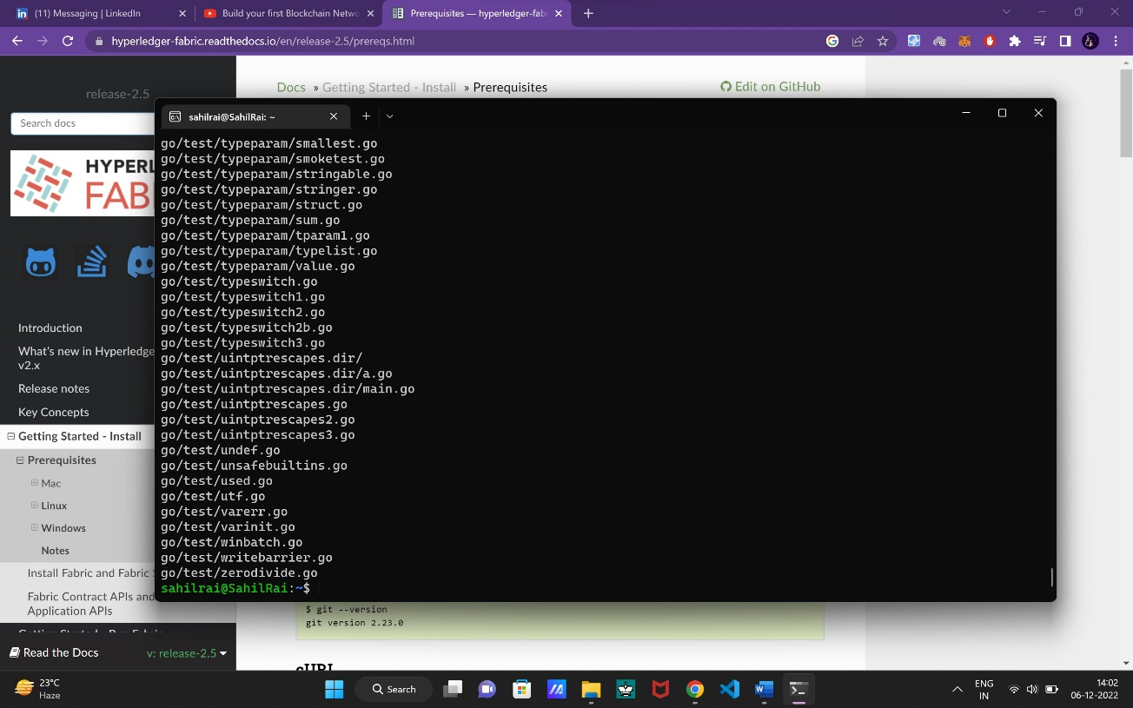

1. Run the below command to move go file in usr/local

sudo mv go /usr/local

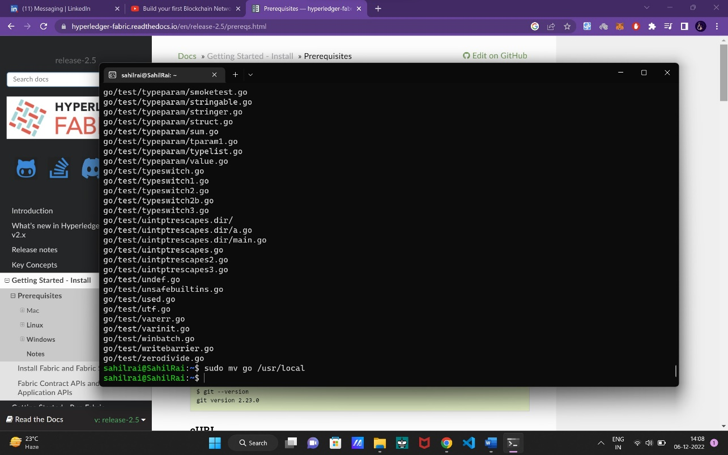

1. To open bashrc file which contain a global variable.

(nano is a editor of linux)

sudo nano ~/.bashrc

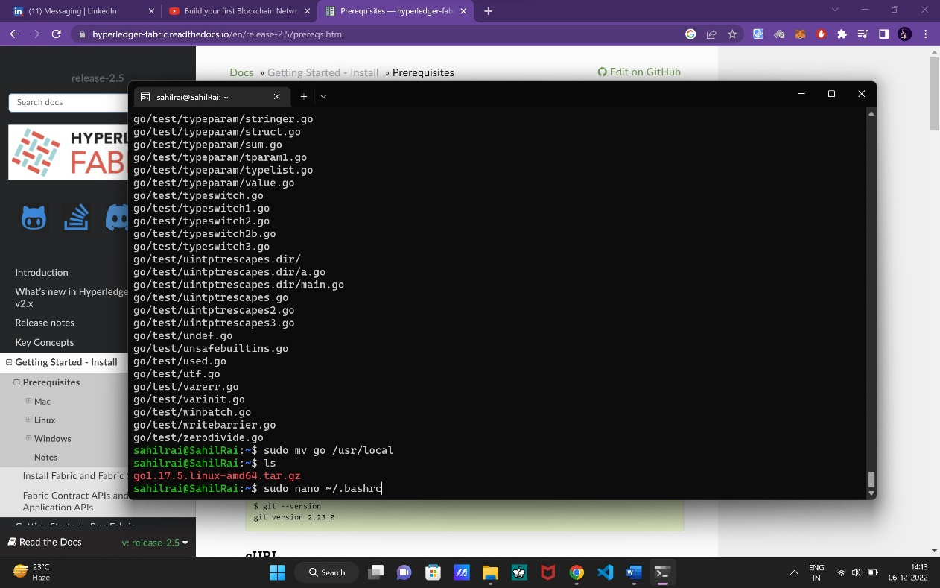

Now press enter.

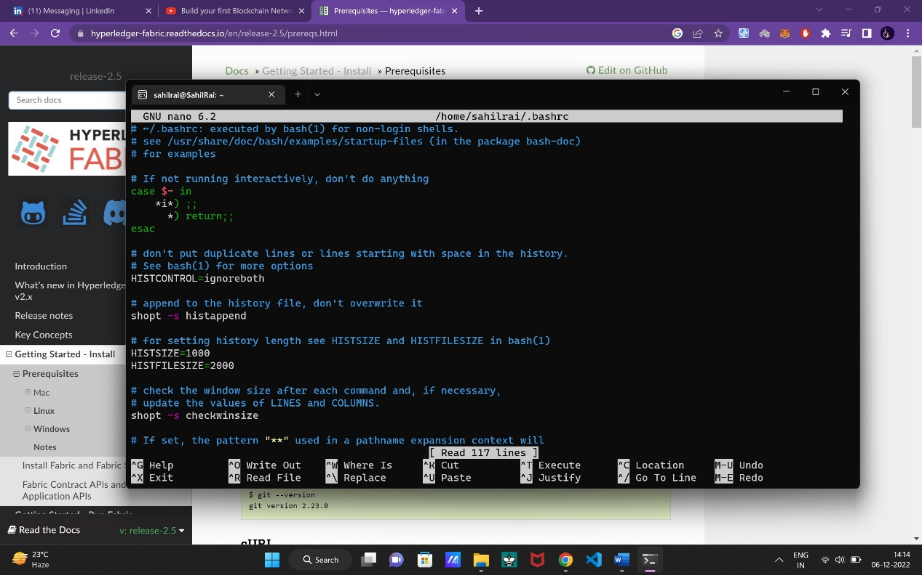

1. Copy paste the below command at the end in nano editor.

export GOROOT=/usr/local/go

export GOPATH=$HOME/go

export PATH=$GOPATH/bin:$GOROOT/bin:$PATH

export PATH=$PATH:/home/sahilrai/go/src/github.com/thesahilrai/fabric-samples/bin

export FABRIC_CFG_PATH=$PWD/go/src/github.com/thesahilrai/fabric-samples/config/

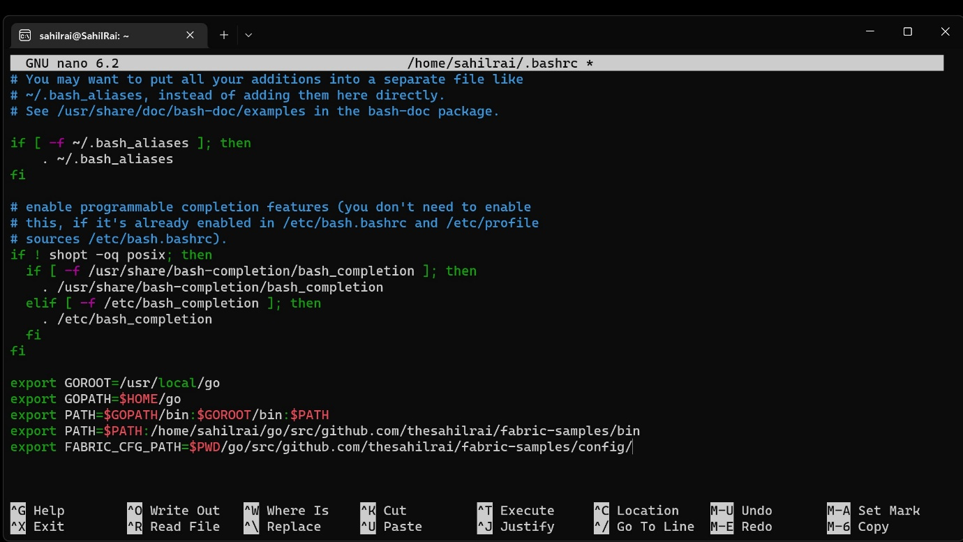

Now to save it “ Ctrl + o ” and press enter.

To exit “ Ctrl + x”.

Now to update session type the below command.

source ~/.bashrc

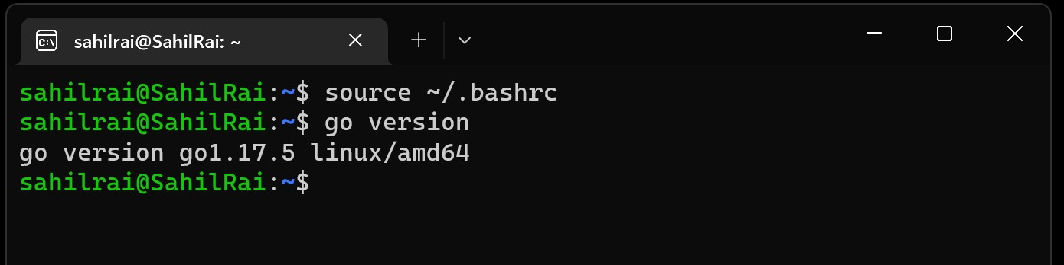

And check the go version. (It is showing ‘go version go1.13.5 linux/amd64’ )

**Now the Prerequisites are downloaded. Next step is to download Hyperledger on your system.**

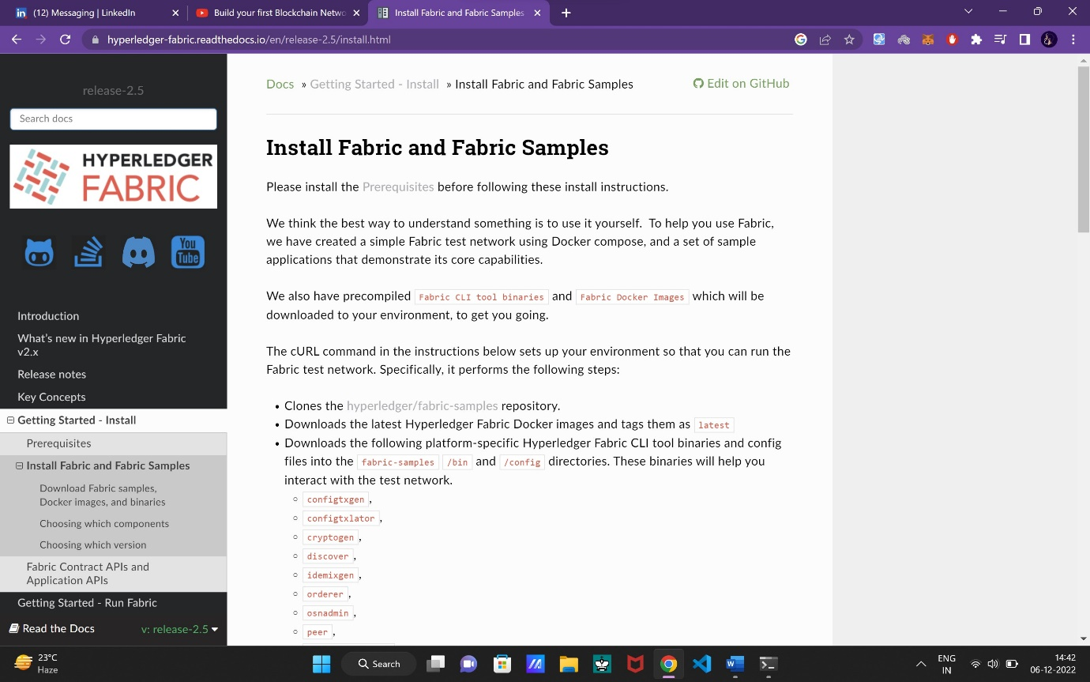

1. Now run the below command
2. mkdir -p $HOME/go/src/github.com/thesahilrai

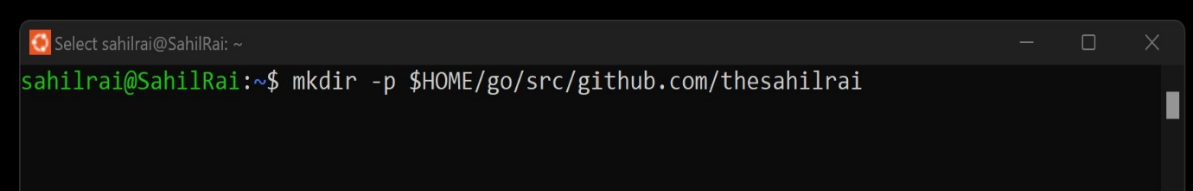

1. cd $HOME/go/src/github.com/thesahilrai
2. curl -sSLO https://raw.githubusercontent.com/hyperledger/fabric/main/scripts/install-fabric.sh && chmod +x install-fabric.sh

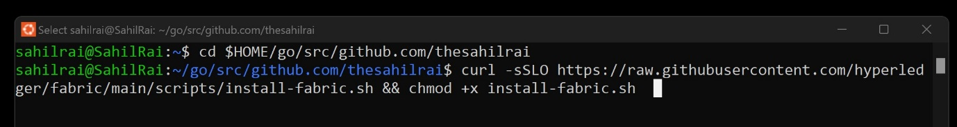

1. ./install-fabric.sh -f 2.4.1

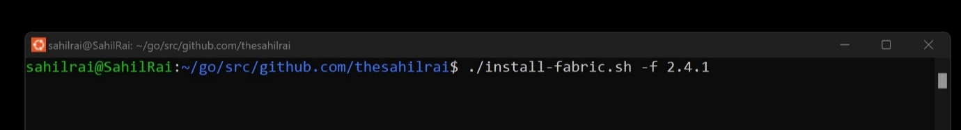

Here you pull the images of Hyperledger Fabric Version 2.4.1 as it is stable and supported by docker 4.1.1

( **Note :** If permission denied error occur the run using sudo.)

**Now the installation part is done. Now you can move to tutorial part.**